The Color of Plants on Other Worlds
Scientific American—April 2008

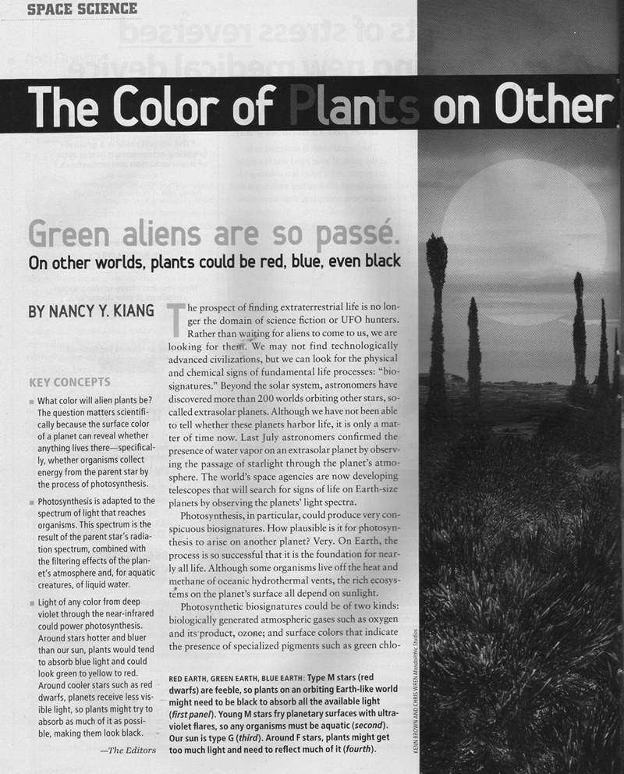
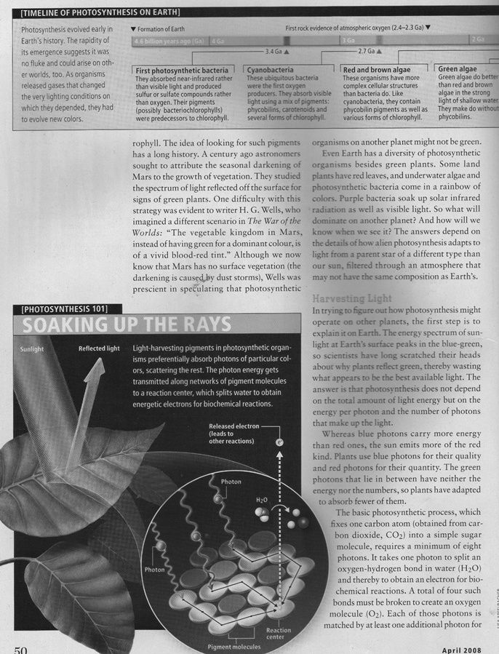
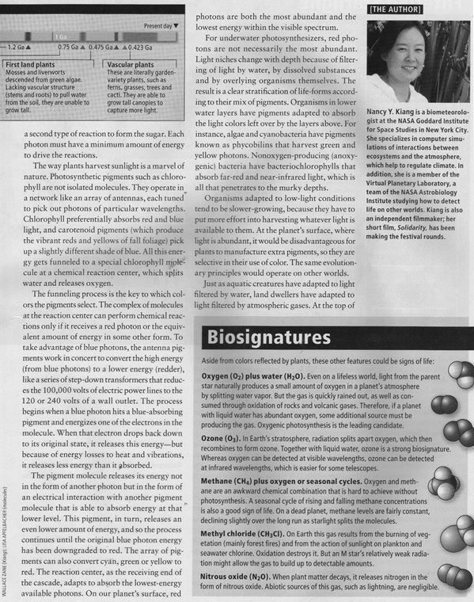
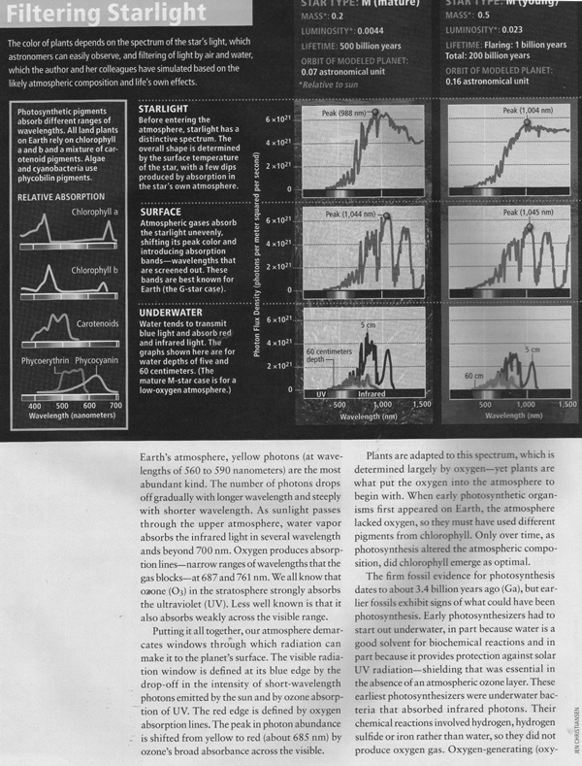
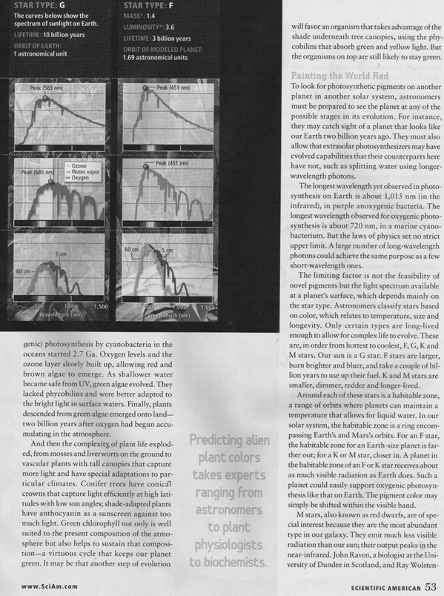
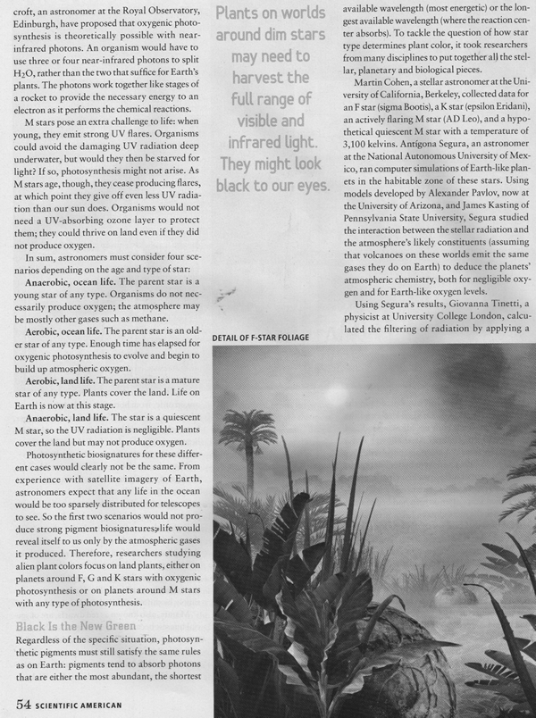
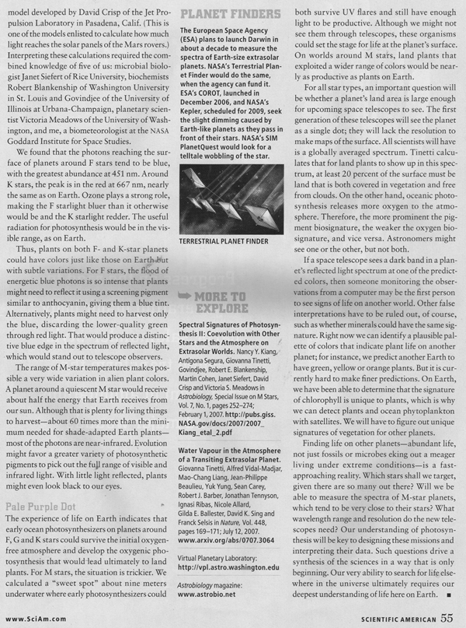
The Color of Plants on Other Worlds
Scientific American—April 2008

- Describe the two kinds of photosynthetic biosignatures that might be detectable.
____________________________________________________________________________________________________________________________________________________________________________________________________________________________________________________________________________________________________________________
- What is the reason why most plants (chlorophyll) reflect green light and absorb blue and red light?

____________________________________________________________________________________________________________________________________________________________________________________________________________________________________________________________________________________________________________________
- Describe why plants adapted to the above on plant earth (page 52).
____________________________________________________________________________________________________________________________________________________________________________________________________________________________________________________________________________________________________________________
- What is the main variable that could determine different color pigments used to absorb light?

____________________________________________________________________________________________________________________________________________________________________________________________________________________________________________________________________________________________________________________
- Why is water most often suspected to be the first place that photosynthesis (and life) originated?

____________________________________________________________________________________________________________________________________________________________________________________________________________________________________________________________________________________________________________________

