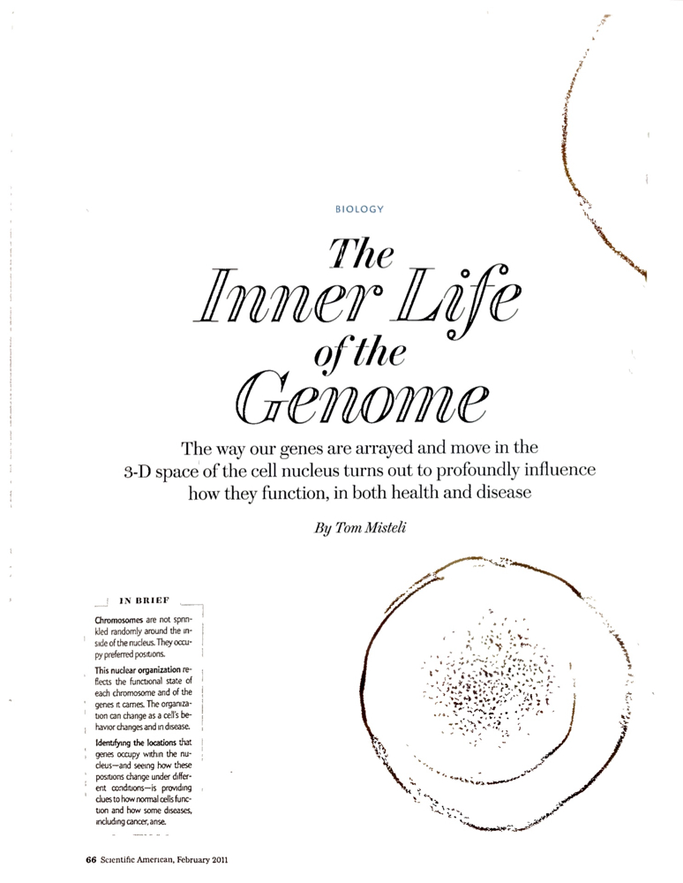
The Inner Life of the Genome
Scientific American – February 2011

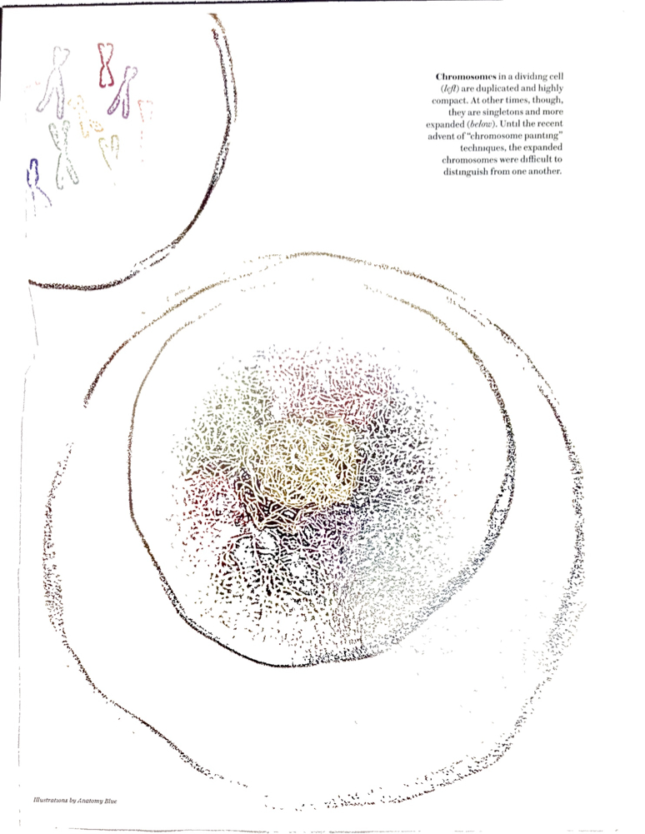
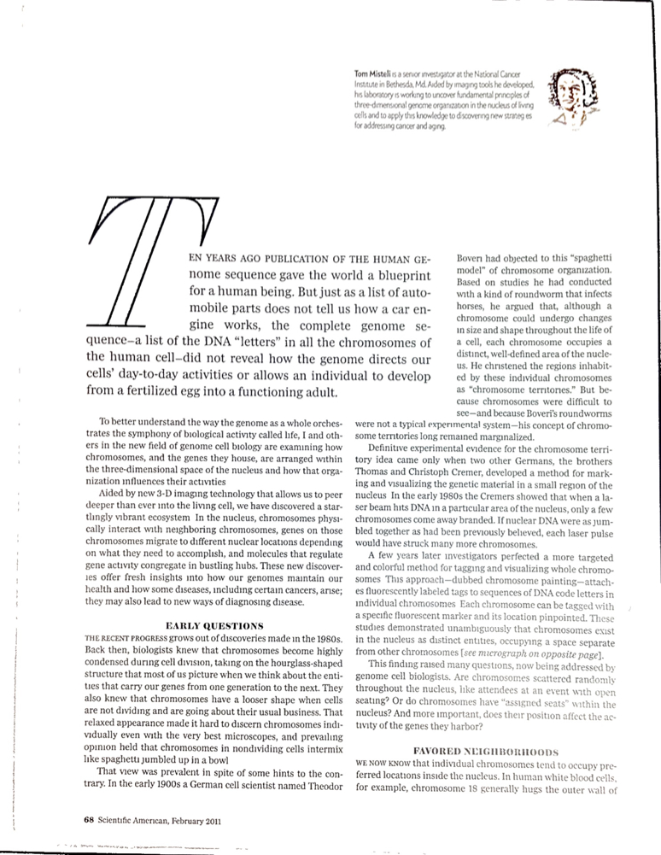
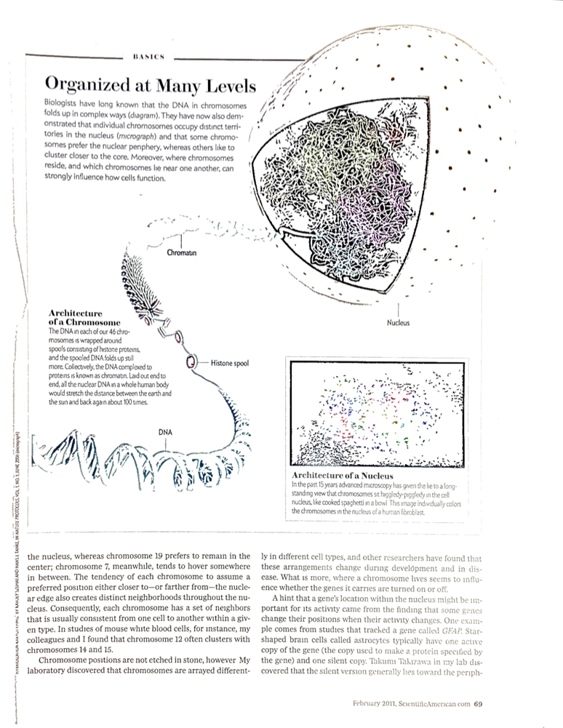

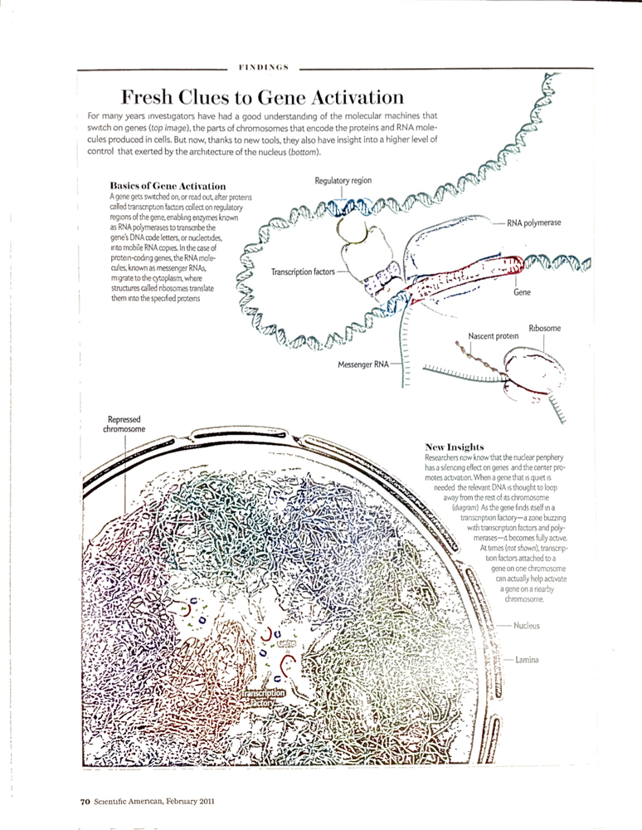
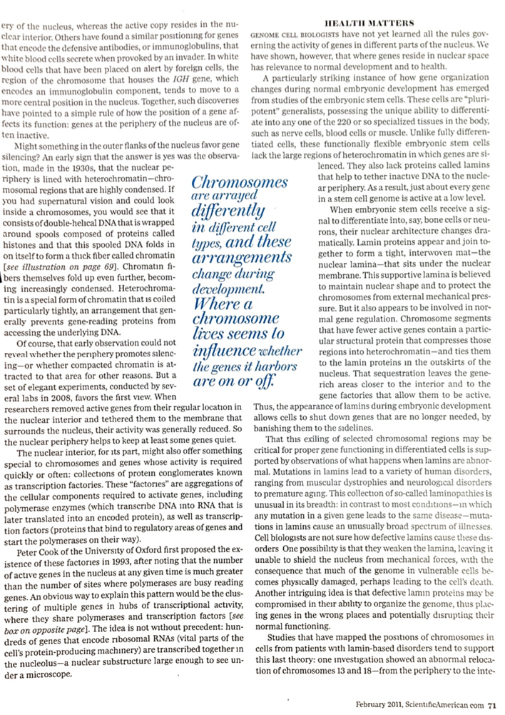
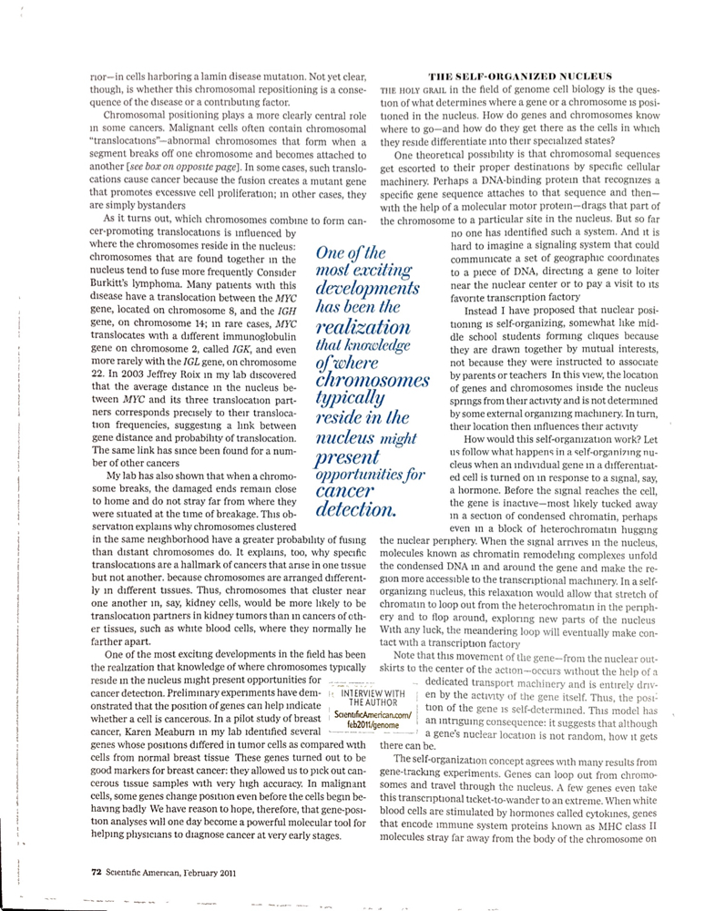
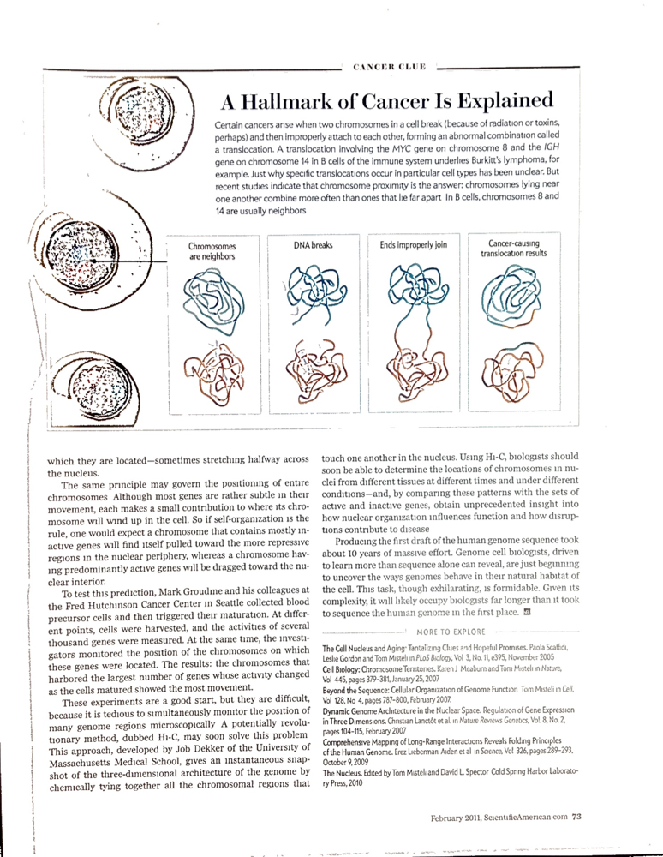

The Inner Life of the Genome
Scientific American – February 2011

- How was it figured out that chromosomes only occupied certain areas of a nucleus?
____________________________________________________________________________________________________________________________________________________________________________________________________________________________________________________________________________________________________________________
- What have observations about the GFAP and IGH genes revealed about gene location?
____________________________________________________________________________________________________________________________________________________________________________________________________________________________________________________________________________________________________________________
- What are transcription factories?
____________________________________________________________________________________________________________________________________________________________________________________________________________________________________________________________________________________________________________________
- How does differentiation affect gene regulation?
____________________________________________________________________________________________________________________________________________________________________________________________________________________________________________________________________________________________________________________
- Describe the role of chromosomal positioning in some cancers.

____________________________________________________________________________________________________________________________________________________________________________________________________________________________________________________________________________________________________________________
- How is (the above) useful in diagnosis of these types of cancer?
____________________________________________________________________________________________________________________________________________________________________________________________________________________________________________________________________________________________________________________
- Describe the self-organization model of a cell nucleus.
____________________________________________________________________________________________________________________________________________________________________________________________________________________________________________________________________________________________________________________

